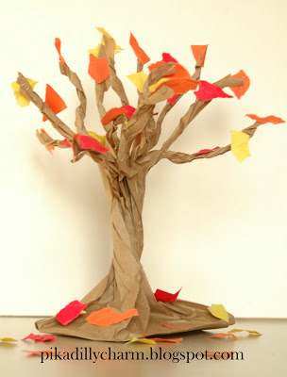
Materials:
-Brown paper lunch bags
-Stiff cardstock/cardboard ¼” smaller
dimensions than bottom of bag
-Scissors
-Glue
-Paper (fall colors) to run copies of leaf
templates (can use paper punches)

Note: If you want groups to work
on ONE bag design, use larger bags,
inserts,and leaves!

DIRECTIONS
1- Cut lunch bag into half inch strips. Start at the opening and cut half way down the bag.
2- Open bag and stand it up.
3- Hold base of bag with one hand and twist the middle of bag to create the trunk of the tree.
4- (example of finished trunk)
5- Twist two of the bag strips together to create branches.
6- (example of finished branches)
7- Rip strips of colored paper into tiny pieces and glue them all over the branches of the tree.

